How to Access Microsoft Teams

First, Access Rapid ID

https://portal.yesnet.yk.ca/
​
or
​
https://v2yesnet.wordpress.com/ and click on "SINGLE SIGN ON"
​
​
If students have logged in before, they need to use their own student number username (studentnumber@yesnet.yk.ca) and the password they have previously created.

If they forgot the password, email the teacher to request a reset. If they have forgoten their student number, please contact the teacher.
​
If the student has NEVER logged in to Rapid ID, they will need to set up the login using their student number username and a default password. How to do that can be found at this link: https://v2yesnet.files.wordpress.com/2020/04/rapid-id-first-log-in-instructions.pdf
​​
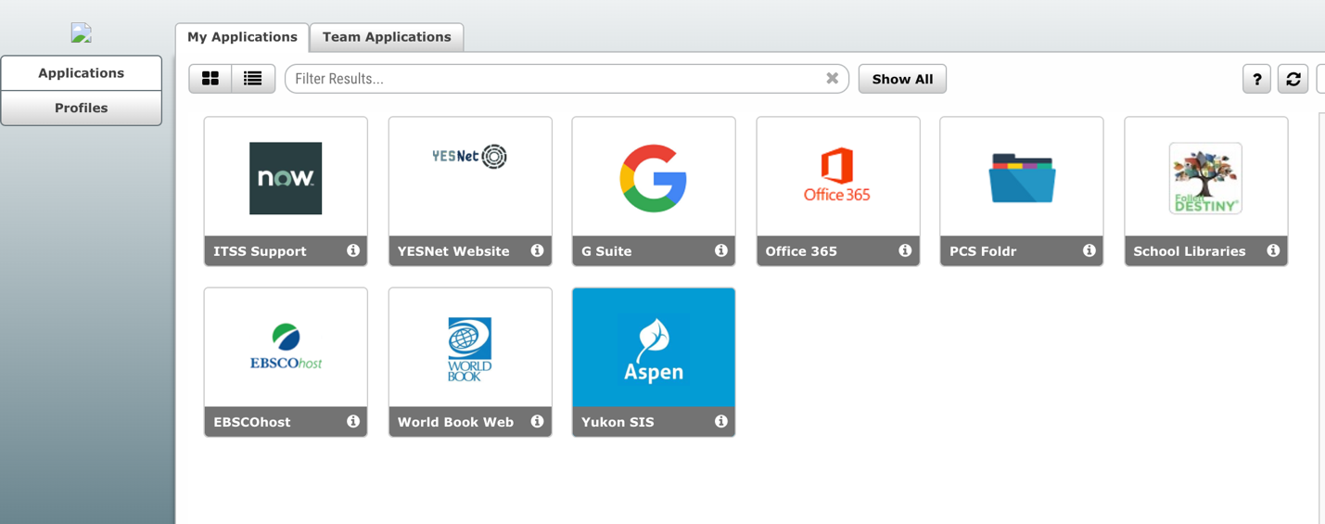
Once students have accessed Rapid Identity, the should see a number of apps, one of which is Microsoft 365:
Select Teams to see which class teams you’re in. Your teacher has already set up the class team and added you. You'll see one or more (depending on how many classes you have) class team tiles. If you don’t see a class team tile, contact your teacher.

When you see your class tiles, click on one to start connecting with your teacher and classmates!

